PSS2 Report

Taszid Chowdhury

1. Smoother.m

#### **Purpose:**

* + 1. This script implements a moving average smoothing operation to reduce noise in data. The results are saved to a CSV file.
  1. Key Features:
     1. Input Parameters:
        1. The independent variable (e.g., time or input values).
        2. y_noisy: The noisy dependent variable.
        3. window_size: The size of the moving average window.
        4. file_name: The name of the output CSV file.
     2. Core Functionality
        1. Applies the movmean function to smooth the noisy data.
        2. Combines x and y_smoothed into a matrix and writes it to a CSV file using csvwrite.
     3. Output:
        1. A smoothed dataset saved in the specified CSV file.

Smoothed Code

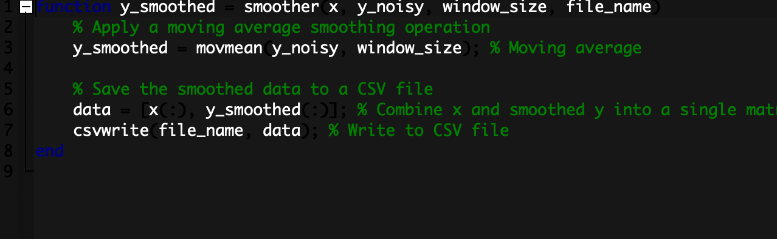

1. Plotter.m
   1. Purpose:
      1. Plots a mathematical function and saves the corresponding data to a CSV file.
   2. Key Features:
   3. Input Parameters:
      1. x: The independent variable (e.g., time or input values).
      2. y: The dependent variable (function values).
      3. title_str: Title for the plot.
      4. file_name: The name of the output CSV file.
   4. Core Functionality:
      1. Creates a plot of x vs. y with a blue line.
      2. Saves the data as a matrix in a CSV file using csvwrite.
   5. Output:
      1. A plot with a grid and labeled axes.
      2. CSV file containing the data.
2. Salter.m
   1. **Purpose**:
      1. Adds random noise ("salt") to data to simulate noisy measurements. The results are saved to a CSV file.
   2. Key Features:
      1. Input Parameters:
         1. x: The independent variable (e.g., time or input values).
         2. y: The dependent variable (function values).
         3. noise_level: The maximum range of random noise.
         4. file_name: The name of the output CSV file.
      2. Core Functionality:
         1. Generates random noise in the range [-noise_level/2, noise_level/2].
         2. Adds the noise to y to create a noisy dataset.
         3. Combines x and y_noisy into a matrix and writes it to a CSV file using csvwrite.
      3. Output:
         1. A noisy dataset saved in the specified CSV file.

Salter Code 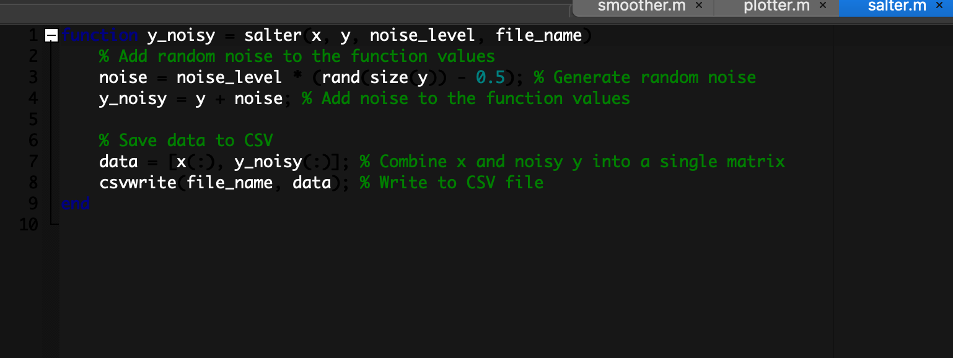

1. Tester.m
   1. **Purpose:**
      1. This script tests the functionality of the plotter, salter, and smoother functions using various data densities and parameter configurations.
      2. Key Features:
         1. Plotter Phase:
            1. Generates and plots data with different sample densities and intervals.
            2. Utilizes the plotter function to visualize data and save it to CSV.
            3. Includes examples such as small samples, very low density, and large high-density data.
         2. Salter Phase:
            1. Adds random noise to the data using the salter function with varying noise levels.
            2. Visualizes the noisy data with red markers on the plot.
         3. Smoother Phase:
            1. Smooths noisy data with the smoother function using different window sizes.
            2. Visualizes the smoothed data with green lines on the plot.
         4. Output:
            1. CSV files and visual plots for each step (raw, noisy, and smoothed data).

Tester Code

Plotter Phase

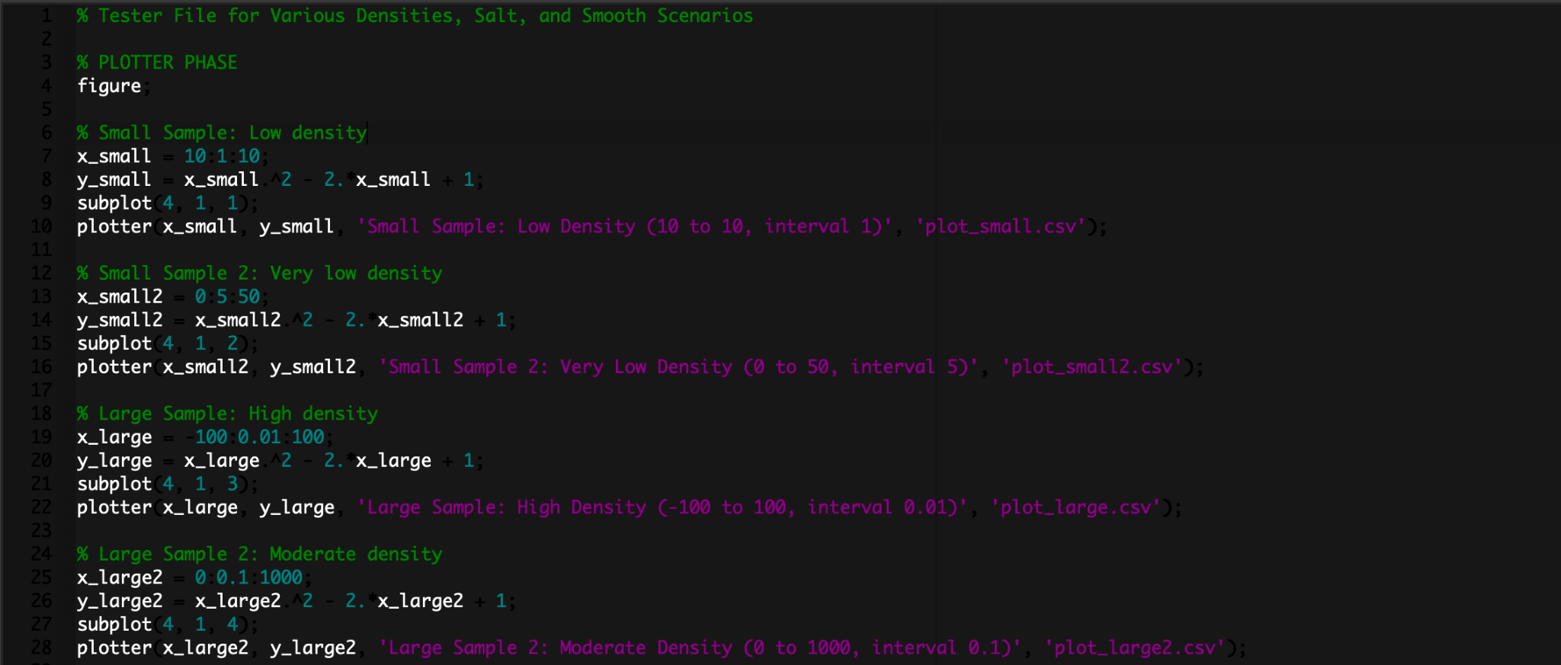

Salter Phase

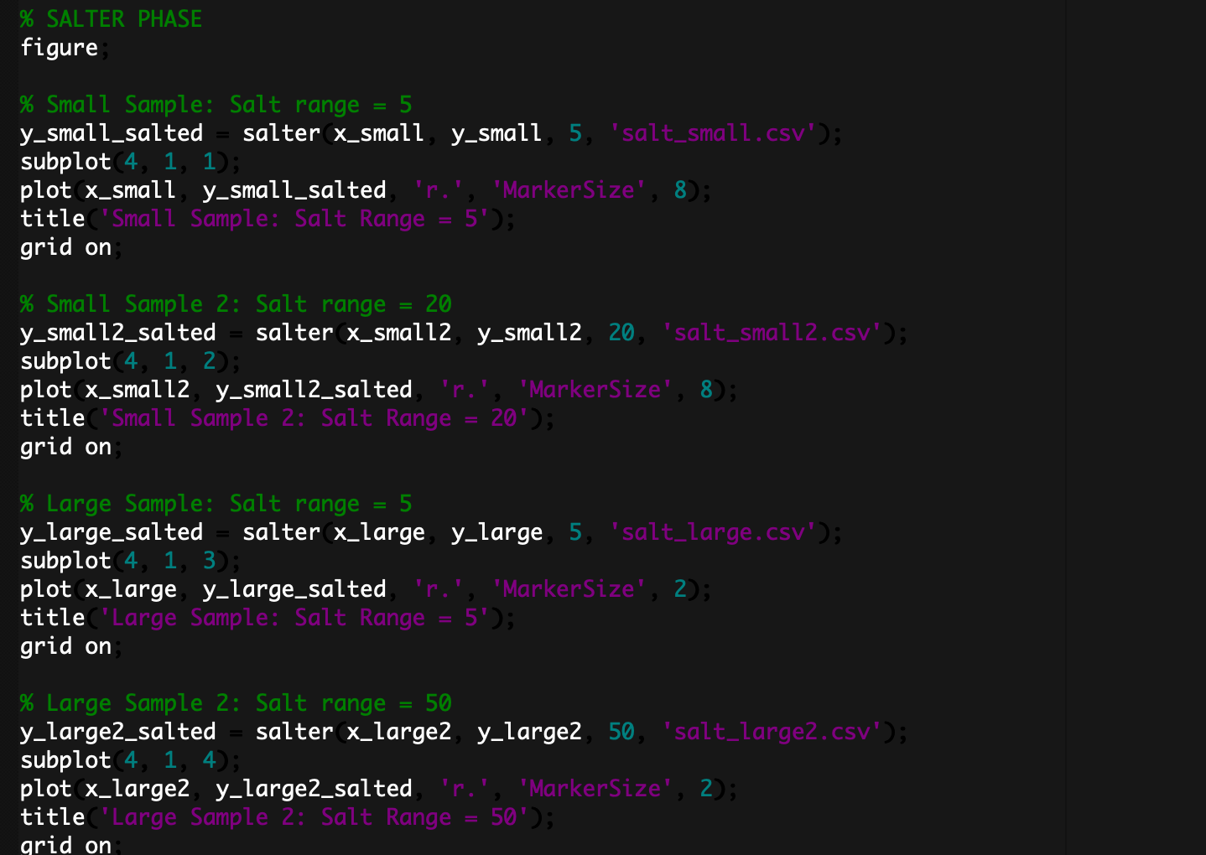

Smoother Phase 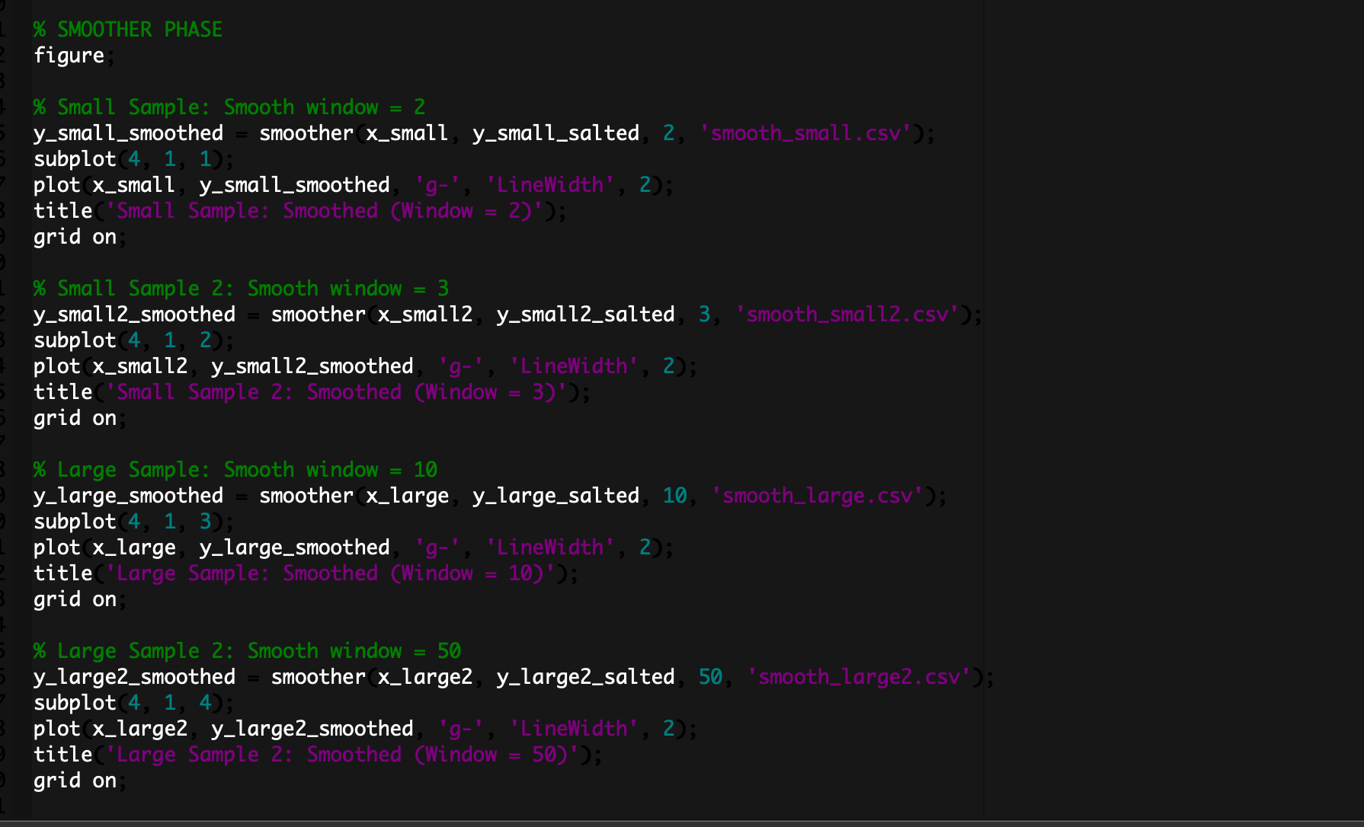

Output

Generated Graphs

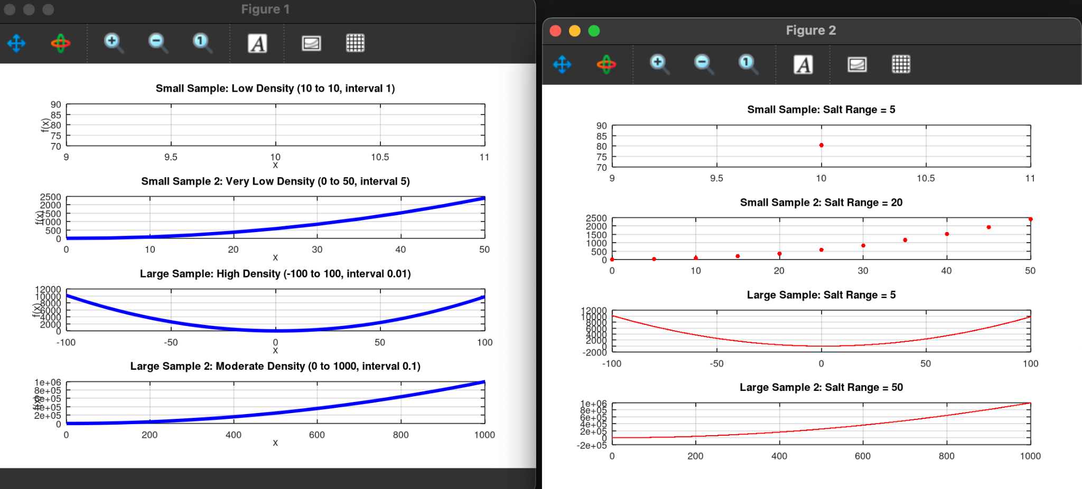

Generated Csv Files

